TI 23 – 09 Technology Example – Isol8 Fusion Annular Isolation Sleeve

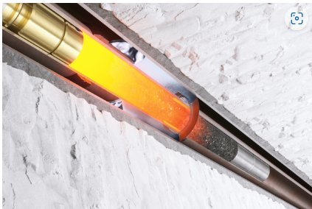

Size
The Fusion tubing packers and annulus casing packers are designed to slip over conventional joints of tubing or casing to metallurgically bond together the most common concentric string sizes.

Heater
isol8’s Fusion tubing packers and annulus casing packers are melted using retrievable thermite heaters that are deployed on wireline or slickline inside the inner string.

Alloy
isol8 is the only alloy company to create a metallurgical bond with the wellbore tubing or casing. This delivers the highest shear-bond strength and longest life expectancy. The optimum alloy is selected based on the well temperature and the alloy length can be varied to achieve the desired strength and pressure rating.

Integral Retainer
The tubing packer and annulus casing packer have been designed with an integral retainer so that our clients can be assured that there is no wasted ratty alloy run-off.

Contingency
The annulus casing packers can be run as a contingency for melting at some future date. This may be to reinstate packer integrity or to prepare the well for abandonment. They can be run above the prognosed cement top to eliminate the risk of sustained casing pressure.

Vendors website link for further information:
Link: Fusion Annulus Casing Packers | isol8

